*The Routledge Encyclopedia of Modernism*

**

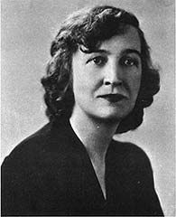

**Ostenso, Martha (1900-1963)**

Martha Ostenso was a critically acclaimed and best-selling author best known for her first novel, *Wild Geese* (1925). Ostenso is significant to the development of Canadian literary modernism for her foundational contributions to “prairie realism,” a literary movement with which Frederick Philip Grove is also associated. Prairie realism rejects romanticized versions of the West for detailed descriptions of the landscape and unsentimental examinations of the physical and mental burdens of prairie settler life.

**Timeline of Life**

Teaches rural school Attends Columbia Publishes first work, Wins Literary Guild Choice award Emigrates to US in Brandon, MA Studies under Durkin *In a Far Land* (poetry)Publishes *O River! Remember!*

1902 1917-18 1921-22 1924 1943

1900 1915 1918 1923 1925 1945 1963

Born Moves from US Attends Moves back to Publishes *Wild Geese* Marries DurkinDeath

Bergen, Norway to Brandon, MA University Minnesota Wins Dodd, Mead, and Co. Seattle, WA

of Manitoba, with Durkin prize for best North American Novel

Winnipeg Wins Pictorial Review prize

Meets Douglas Durkin

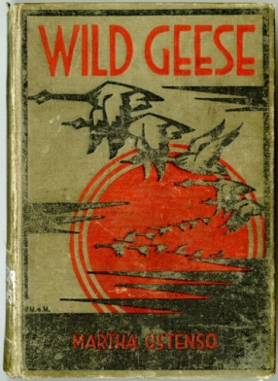

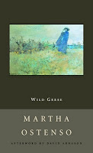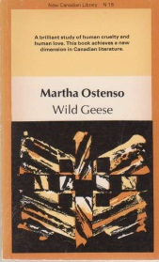*Wild Geese* has, in particular, been canonized as a landmark work in modern Canadian realist fiction. The novel unravels homesteader Caleb Gare’s imposition of patriarchal, anthropocentric constructions on the family and on the land by positioning these constructions against natural cycles of fecundity and decay. Caleb’s poetically just death by flaming muskeg adds a romantic flourish to the novel’s otherwise stark realism. Wild Geese received a $13,500 prize for year’s best novel from Dodd, Mead, and Co., and the first novel-prize offered by the Pictorial Review. Its canonical status in Canada is evinced by its ongoing reprints in McClelland’s definitive New Canadian Library (NCL) series, most recently in 2008. Though there is speculation that much of Ostenso’s oeuvre was collaboratively created with Douglas Durkin, most critics believe that *Wild Geese* was written exclusively by Ostenso. Ostenso’s later novel *O River! Remember!* (1943) was honored with a Literary Guild Choice award. Ostenso died in November 1963.

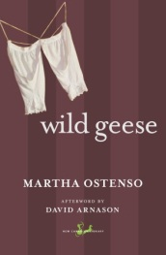

**Selected Bibliography**

*In a Far Land.* New York: Seltzer, 1924.

*Wild Geese.* Toronto: McClelland and Stewart, 1925.

*The Dark Dawn*. New York: Dodd, Mead and Co., 1926.

*The Mad Carews.* New York: Dodd, Mead and Co., 1927.

*The Waters Under the Earth.* New York: Dodd, Mead and Co., 1930.

*Prologue to Love.* New York: Dodd, Mead and Co., 1931.

*There’s Always Another Year.* New York: Dodd, Mead and Co., 1933.

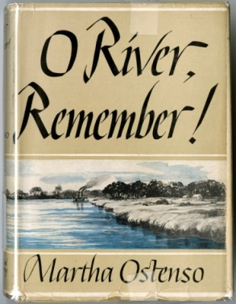*The White Reef.* New York: Dodd, Mead and Co., 1934.

*O River! Remember!* New York: Dodd, Mead and Co., 1943.

*Milk Route.* New York: Dodd, Mead and Co., 1948.

*The Sunset Tree.* New York: Dodd, Mead and Co., 1949.

*A Man Had Tall Sons.* New York: Dodd, Mead and Co., 1958.

